1.0 BLACK FLOOD HAS ARRIVED NIGERIA

The River Niger Black Flood from Guinea has arrived Nigeria. It was recorded at the NIHSA’s hydrological gauge station at Jiderebode upstream Kainji dam where it has started gradually increasing from the 16th December with a maximum discharge of 1,806 m3/s recorded on 31st December 2020 (Figure1).

River Niger has two periods of flood flows known as the White Flood and the Black Flood. The White flood occurs during the rainy season while the Black Flood which originates from Guinea, occurs during the dry season from December to May of the following year with a peak flow expected in either January or February. The Black flood is the major water sources to Kainji and Jebba dams that also protect the downstream areas of the country against flood disasters.

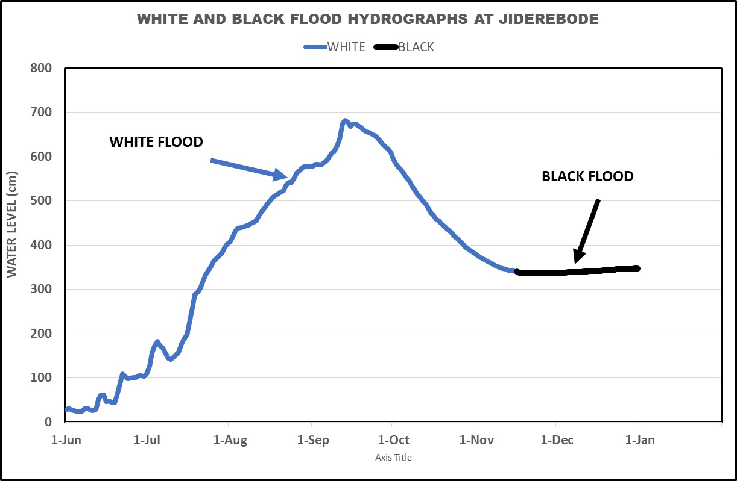

Figure. 1: Hydrograph of White and Black of River Niger at Jiderebode.
2.0 BLACK FLOOD IS RISING IN NIAMEY, NIGER REPUBLIC

The Black Flood flow of River Niger from Guinea is rising in Niamey, Niger Republic, upstream of Nigeria in December 2020 with a maximum Water Level (WL) 5.73m corresponding to a discharge of about 2,084 m³/s recorded om 31st December 2020 and expected to attain its peak in January 2021 (Figure 2).

The Riparian populace along the river Niger floodplain are strongly advised to take necessary precaution to prevent flood disasters.

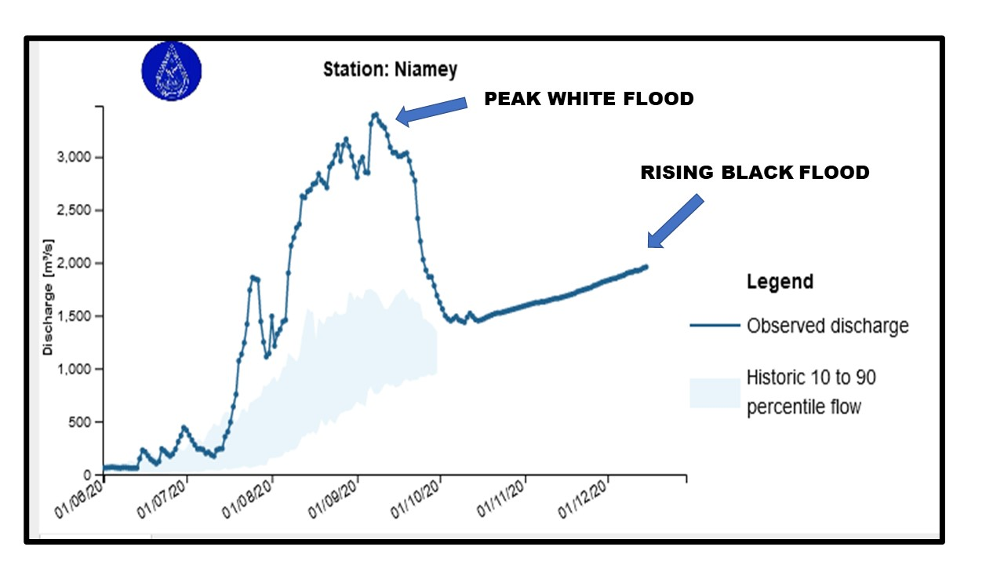
Fig. 1: Hydrograph of River Niger in Niamey Niger Republic.

3.0 LOW WATER LEVEL AT LOKOJA

In December 2020, the flow of River Niger at Lokoja (Kogi State), confluence of Rivers Niger and Benue has been decreasing with a WL of 3.59m corresponding to a discharge of about 3,615 m³/s on 30th December 2020.

The 2020 Comparative Hydrographs of River Niger at Lokoja with that of 2018 and 2012 hydrological years is shown in Fig 3.

Fig. 3: Comparative Hydrographs of rivers Niger and Benue at Lokoja.

4.0 RIVER BENUE FLOW RECEEDING AT MAKURDI

In December 2020, the flow along River Benue at Makurdi, Benue State, is decreasing with a WL of 4.18m corresponding to discharge of about 461 m³/s on 30th December 2020.
The 2020 and 2018 Comparative Hydrographs of River Benue at Makurdi showing a decreasing flow trend is shown in Fig. 4.

Fig. 4: Comparative Hydrographs of Rivers Benue at Makurdi.

5.0 FANFAR OPERATIONAL FLOOD FORECASTING AND ALERT FOR THE MONTH OF OCTOBER 2020 IN NIGERIA
The European Union Assisted Project – “Reinforced Cooperation to provide Operational Flood Forecasting and Alerts in West Africa (FANFAR)” forecast for Nigeria in December, 2020 (Figure 9) showed low flow event in most parts of the country due to cessation of rainfall except at the Jiderebode upstream Kainji dam where the arrival of transboundary Black flood is expected from upstream Nigeria with high severity (level 2).
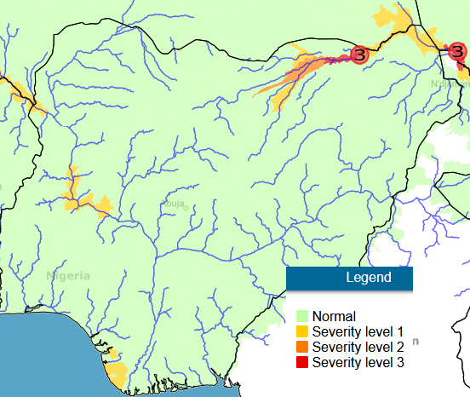
Figure 9: FANFARE Flood Alert.

REFERENCES
- Hydrological Data from NIHSA Gauge Stations
- www.sath.abn.ne .
- www.fanfar.eu
- www.platform.princetonclimate.com
- www.climateservice-global.eu

