BLACK FLOOD ATTAINED MAXIMUM PEAK FLOW IN NIGERIA

The Transboundary Black Flood` flow of River Niger that is coming from the Republic of Guinea has attained its maximum peak flow in Nigeria, upstream Kainji dam at Jiderebode (Kebbi Sate). The maximum peak Water Level (WL) recorded was 355cm corresponding to a discharge of 1,61689 m³/s on 26th February 2021 as shown in Figure 1.
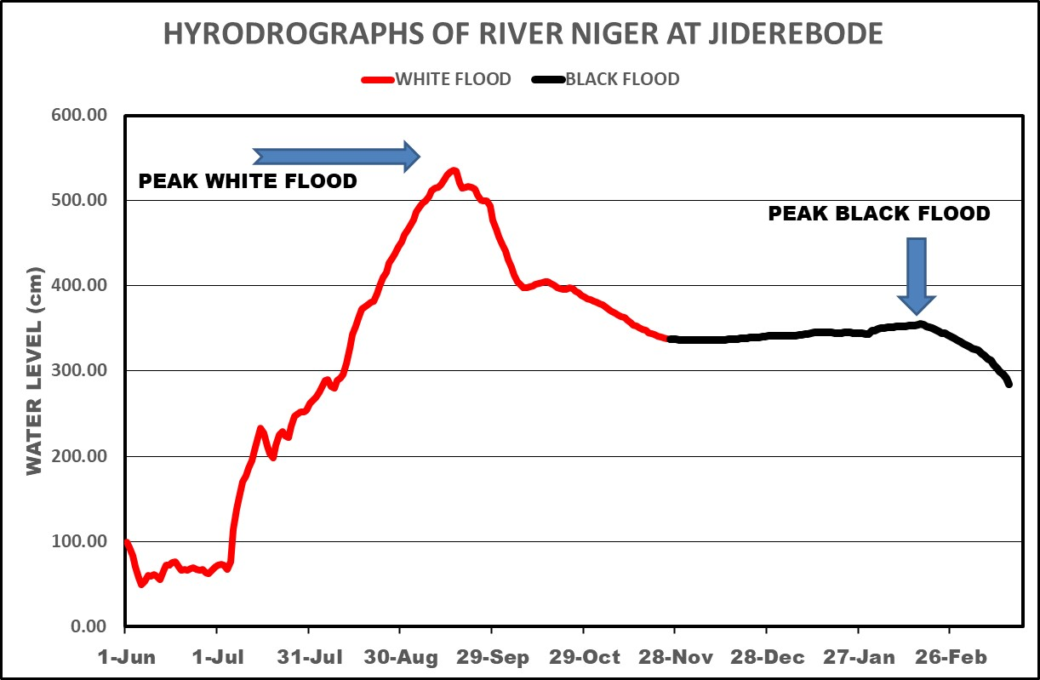
Figure 1: Hydrograph of River Niger at Jiderebode Upstream Kainji Dam.

The Black Flood is usually absorbed to refill the Kainji and Jebba dams in the dry season and therefore has no major negative impact on the downstream communities in the country. Nevertheless, Riparian populace downstream should still be on alert.

2.RIVER NIGER COMPARATIVE HYDROGRAPHS IN NIGERIA
The comparative Hydrographs of river Niger at Jiderebode, upstream Kainji dams shows that flow recorded in 2020/2021 hydrological year was lower than those recorded in 2018/2019 and 2012/2013 as shown in Figure 2.
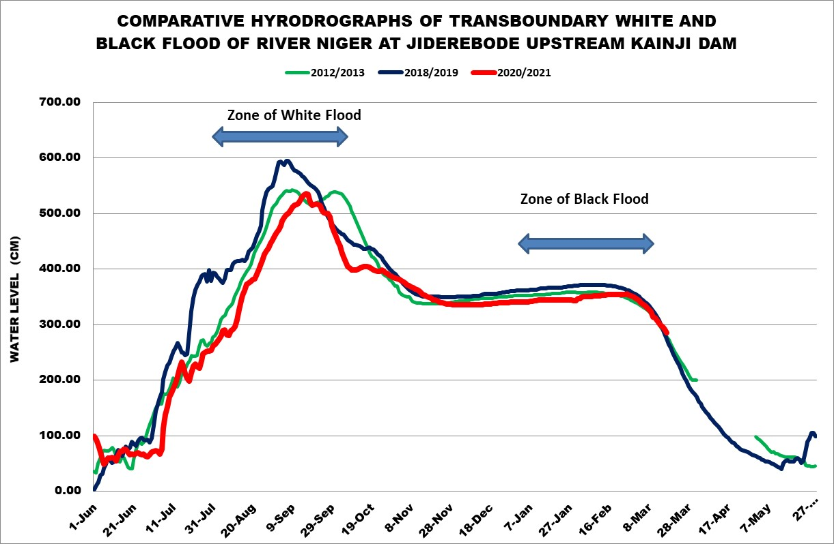
Figure 2: Comparable Hydrographs of 2020/2021 with 2018/0219 and 2012/2013

3.0 SITUATION OF RECEDING BLACK FLOOD IN NIAMEY

The Transboundary Black Flood flow of River Niger in Niamey, Niger Republic, upstream Nigeria has continued receding after attaining the peak flow WL of 582cm corresponding to a discharge of 2,145 m³/s that was recorded on 20th January 2021.

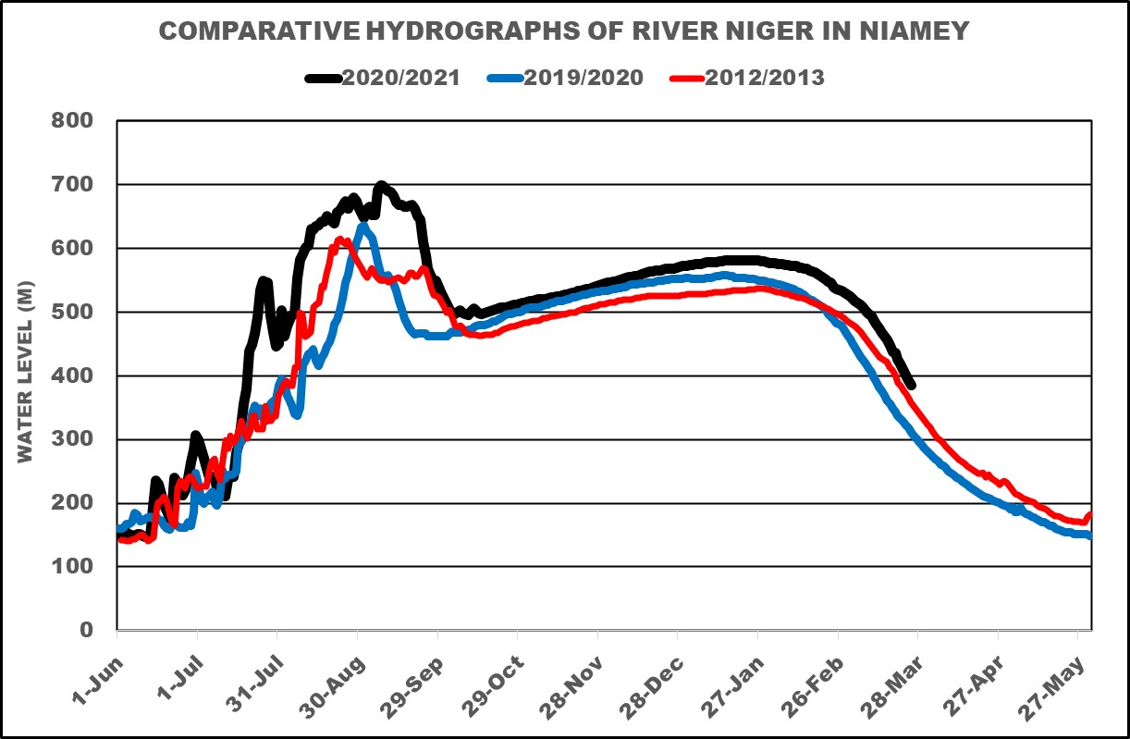
Figure 3: Comparable Hydrographs of River Niger in Niamey 2020/2021 with 2019/2020 and 2012/2013

The comparative Hydrographs of river Niger in Niamey, upstream Nigeria showed that White and the Black Flood flows recorded in 2020/2021 hydrological year which was higher than those recorded in 2019/2020 and 2012/2013 was also the highest in recent time as shown in Figure 3.

.

4.0 RIVER NIGER FLOW SITUATION AT LOKOJA

The flow situation of River Niger at Lokoja (Kogi State), confluence of Rivers Niger and Benue, has continue decreasing with a maximum WL of 3.23m corresponding to a discharge of about 2,794 m³/s that was recorded on 31st January 2021 at the NIHSA Gauge Station at Lokoja.

The 2020/2021 hydrological year has a lower flow when compared with 2019/2020 and 2012/2013 hydrological years as shown in the Comparative Hydrographs of River Niger at Lokoja in Figure 4.

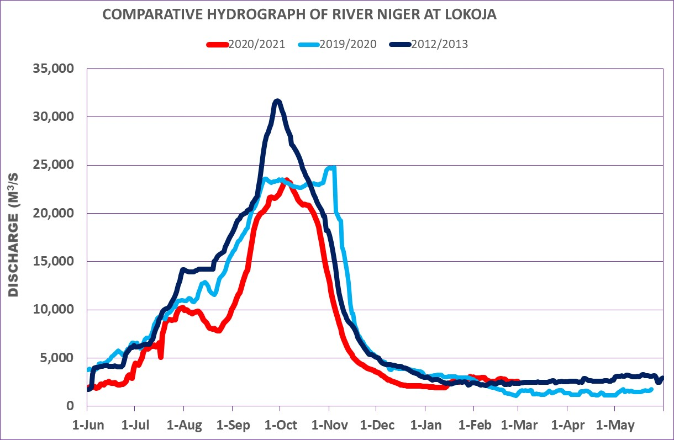
Figure 4: Comparative Hydrographs of rivers Niger and Benue at Lokoja.

4. RIVER BENUE FLOW SITUATION AT MAKURDI

The flow of River Benue at Makurdi (Benue State), has also been receding after recording a maximum WL of 10.08m corresponding to a discharge of about 13,260 m³/s recorded on 20th October 2020 at Makurdi NIHSA Gauge Station.

The flow of river Benue during the 2020/2021 hydrological year was lower than those in 2019/2020 and 2012/2013 hydrological years as shown in the Comparative Hydrographs of River Benue at Makurdi in Figure 4.

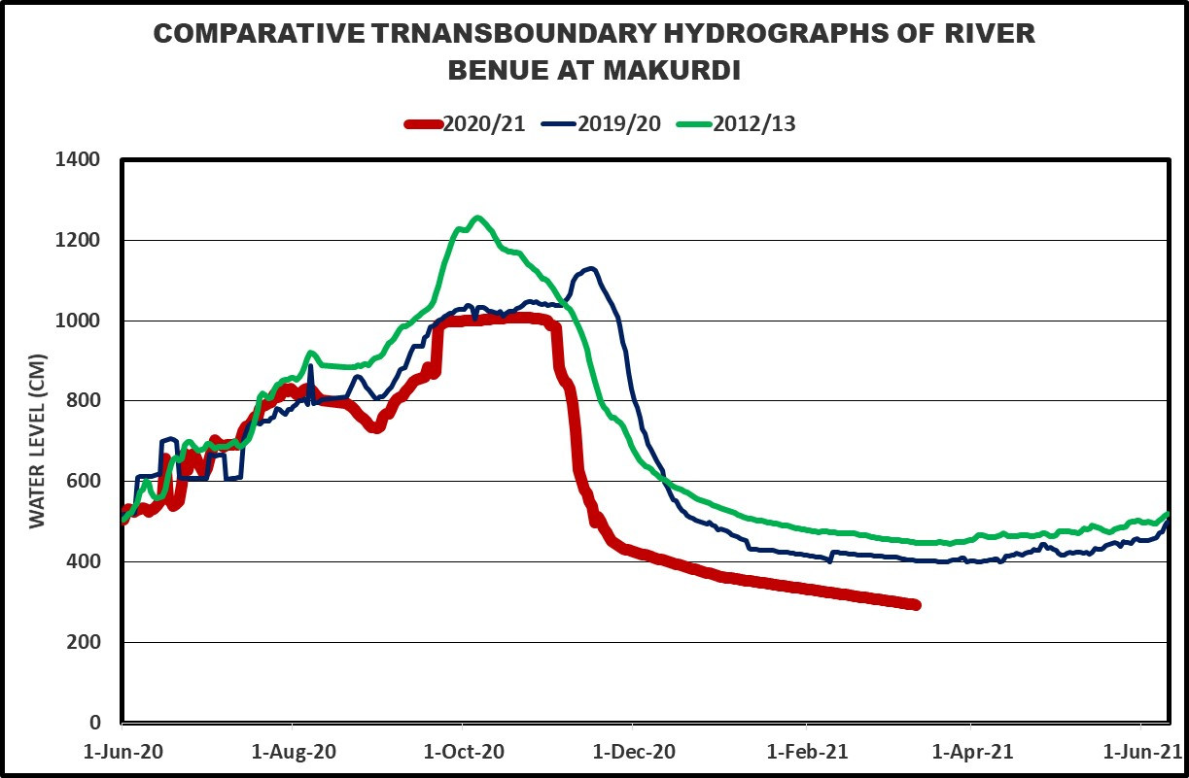
Comparative Hydrographs of River Benue at Makurdi

5.0 CLIMATE REPORT FROM SATELLITE HYDROLOGY IN NIGERIA
5.1 HYDROLOGICAL DROUGHT INDEX
The Niger Basin Authority (NBA) Satellite Hydrology (SATH) project that covers the Niger Basin areas in Nigeria, showed that Hydrological Drought Index in February 2021 ranges between -25% to 50% in most parts of Country as shown in Figure 5.

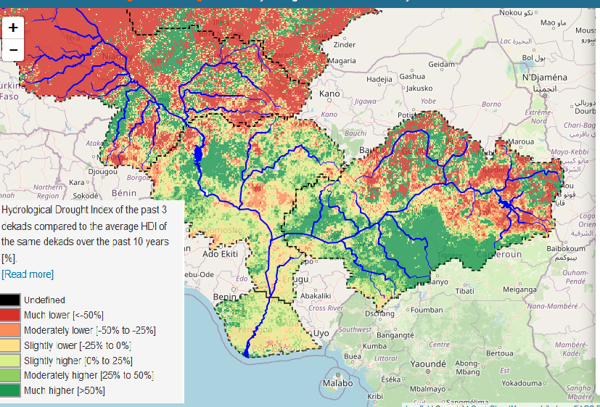
Figure 5: Hydrological Drought Index in Nigeria in February 2021.

5.2 ACTUAL EVAPOTRANSPIRATION IN NIGER BASIN
The NBA Satellite Hydrology project covering the Niger Basin part of Nigeria showed that Actual Evapotranspiration (ETa) in the country ranges from 0 to 4 in most parts of the country in February 2021 as shown in Figure 6.

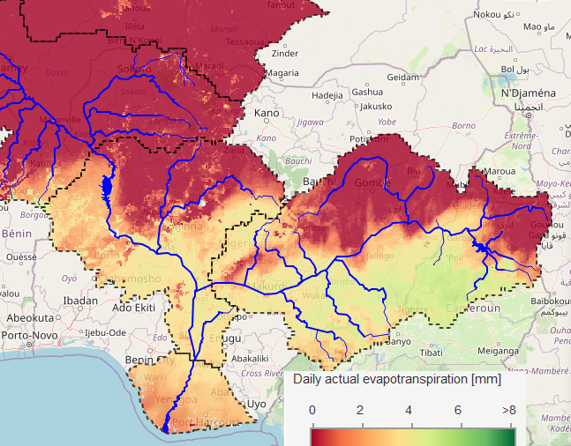
Figure 6: Actual Evapotranspiration (ETa) in the River Niger Basin

54.3 METEOROLOGICAL DROUGHT INDEX IN NIGERIA
The SATH project satellite information on the Niger Basin areas in Nigeria, showed that the Meteorological Drought Index in February 2021 ranges between -25% to 50% as shown in Figure 5.

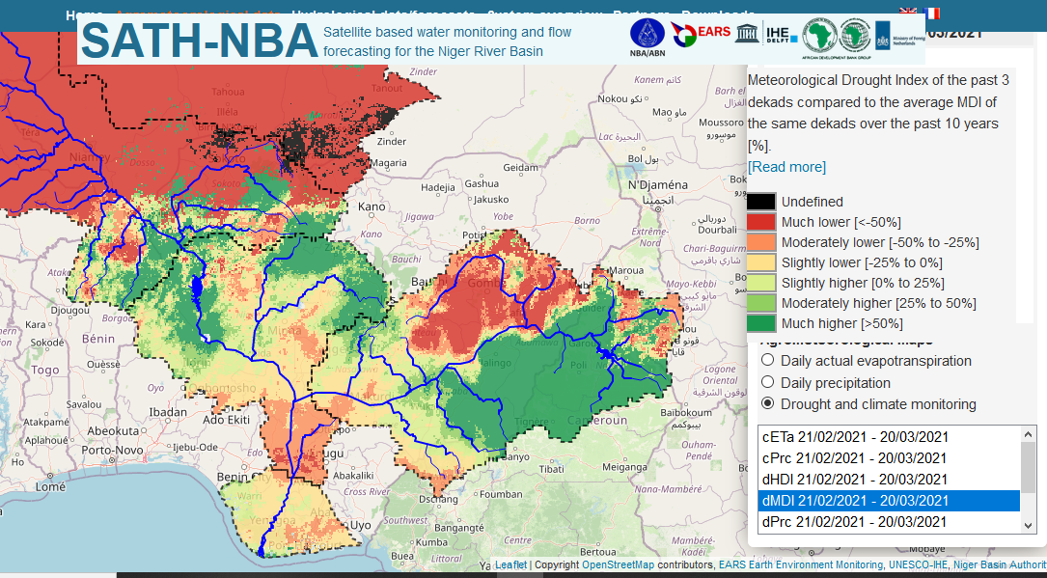
Figure 7: Relative Soil Moisture Index in Nigeria

5.5 FEBRUARY 2021 FANFAR FORECAST IN NIGERIA
The European Union Assisted Project – “Reinforced Cooperation to provide Operational Flood Forecasting and Alerts in West Africa (FANFAR)” forecast for Nigeria in February, 2021 showed low flow event in most parts of the country due to cessation of rainfall except at the Jiderebode upstream Kainji dam where the arrival of transboundary Black flood has reached its peak flow with high severity level 1 as shown in Figure 8.
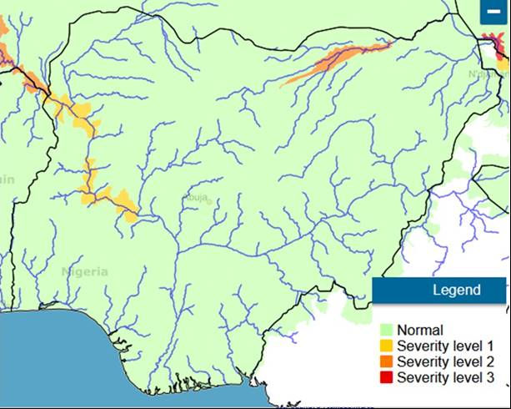
Figure 8: FANFAR Forecasting for the Month of January 2021 in Nigeria

REFERENCES
- Hydrological Data from NIHSA Gauge Stations
- www.sath.abn.ne .
- www.fanfar.eu
- www.platform.princetonclimate.com
- www.climateservice-global.eu

