LAGOS STATE ISSUED FLASH FLOOD WARNINGS ALERT FOR 2021
The Lagos State government has issued flash flood warning alert after the prediction of high intensity rainfall of 261 days. The 2021 rainy season with attendant flash flooding across the state was made known during the media briefing of “2021 Seasonal Climate Predictions and Socio-Economic implications for Lagos State” held at Alausa, Ikeja. It therefore strongly worn residents especially those along coastal and the floodplains wetland areas to be proactive, more vigilant and relocate to safer areas to avert flood disaster and save lives and properties (Figure 1).

Figure 1: Wetland Area Flooding in Lagos State (Vanguard News)

Meanwhile the flood disaster that occurred in Ilorin, Kwara State Capital after two heavy rainfall in the city has caused loss of properties worth millions of Naira. The State Government is expanding the Asa dam upstream to increase its reservoir storage capacity to be able to absorb floodwaters and curtail future flooding in the State (Figure 2).
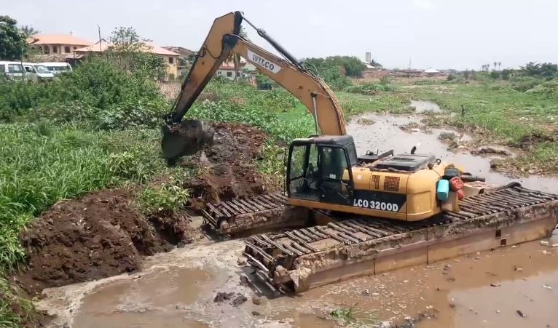
Figure 2: Expansion of Asa dam in Ilorin, Kwara State

2.0 BLACK FLOOD FLOW SITUATION IN NIGERIA
The River Niger Black flood flow in Nigeria at Jiderebode, upstream Kainji dam has continued decreasing in April 2021 with a minimum discharge of 150 m³/s recorded on 30th April 2021 after attaining a maximum discharge of 1,914 m³/s on the 6th February 2021. The maximum White Flood discharge of 5,389 m³/s was recorded on 12th September 2020 during the 2020/2021 hydrological year. The Black Flood flow is transboundary emanating from Guinea and provides additional inflows into Kainji and Jebba dams in the dry season (Figure. 3)
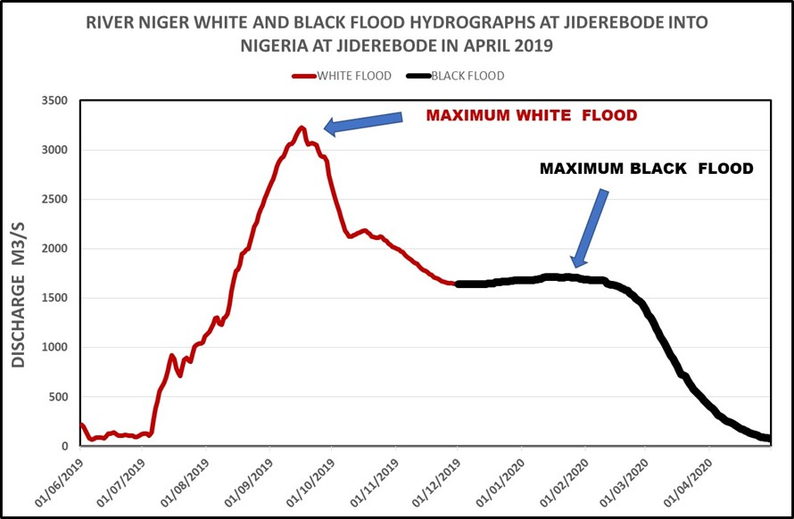
Fig. 2: Hydrograph of River Niger White and Black Flood in Nigeria at Jiderebode

4.0 RIVER NIGER FLOW SITUATION AT LOKOJA
The River Niger flow situation at Lokoja, Kogi state, has continue receding April 2021 with minimum discharge of 2,910 m³/s recorded on 30th April 2021 after attaining a maximum discharge of 28,082 m³/s on 5th October 2020. The Comparative Hydrographs River Niger at Lokoja showed that the flow recorded in 2020/2021 hydrological year was lower than that of 2012/2013 but higher than that in 2019/2020 (Figure 5).

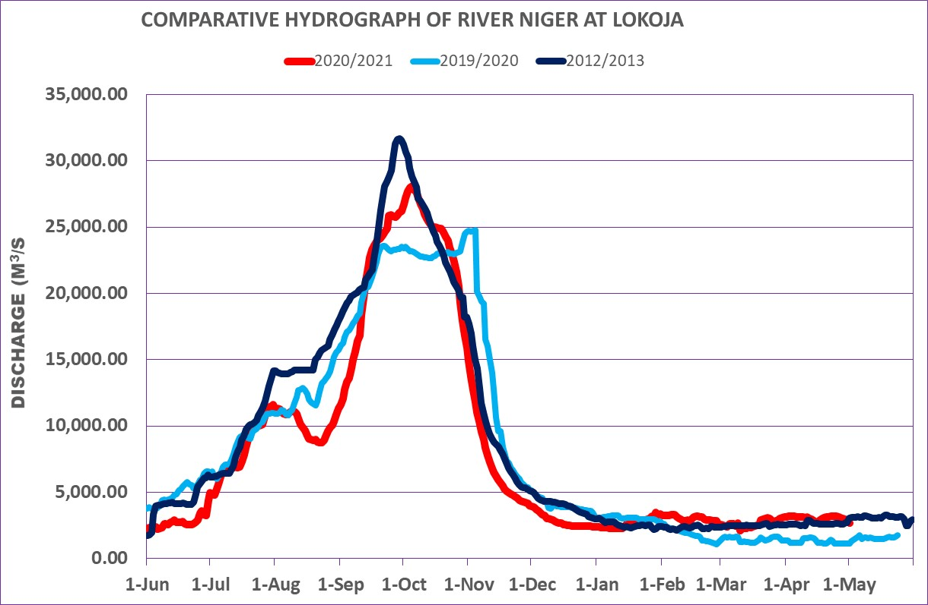
Fig 5: Comparative Hydrographs of river Niger and Benue at Lokoja

4.0 RIVER BENUE FLOW SITUATION AT MAKURDI
The River Benue at Makurdi has continued receding with minimum discharge of 322 m³/s which occurred on 30th April 2021 after attaining a maximum discharge of 11,376 m³/s that occurred on 23rd October 2020. The Comparative Hydrographs River Benue at Makurdi showed that the flow recorded in 2020/2021 hydrological year was lower than those of 2012/2013 and 2019/2020 (Figure 4).
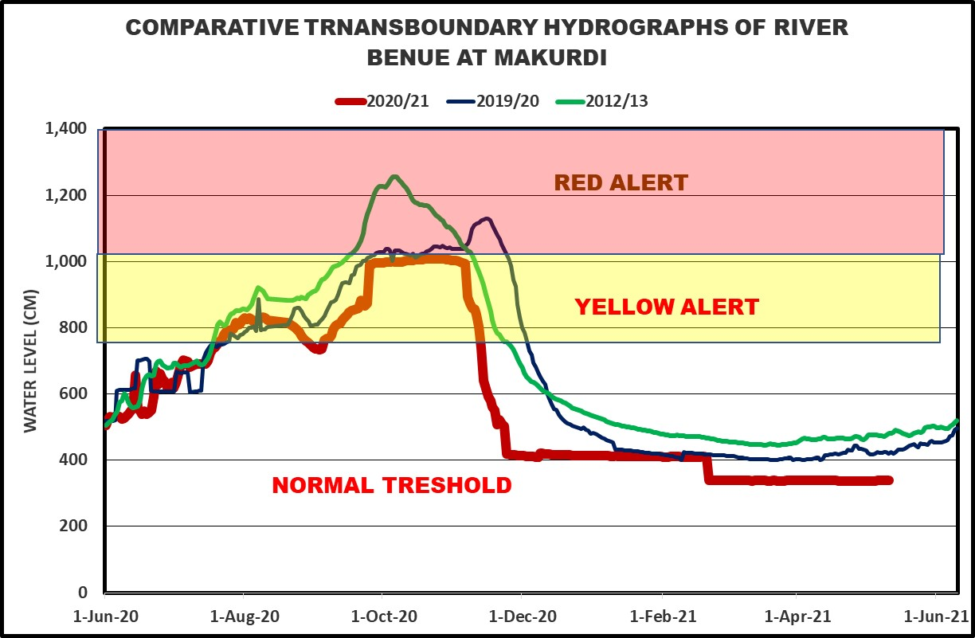
Figure 4: Hydrograph of River Benue Makurdi

5.0 HYDROLOGICAL DROUGHT INDEX FORECAST
5.1 Expected Actual Evapotranspiration
The Actual Evapotranspiration rate forecast in May 2021 will range from 0 to 1 mm/day in most parts of the country except the coastal areas where it will be between 2 to 4 mm/day (Figure. 6).

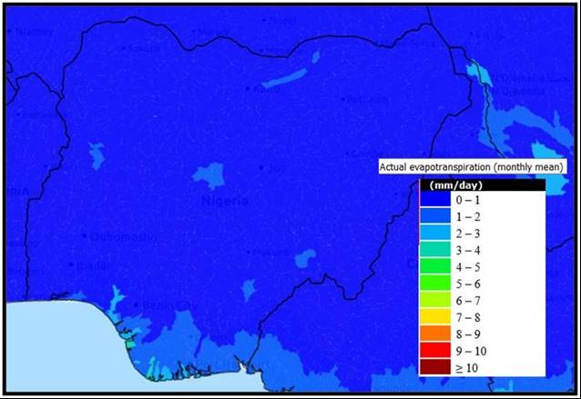
Fig. 6: Mean Monthly Actual Evapotranspiration Forecast in May 2021

5.2 Expected Potential Evapotranspiration
The Potential Evapotranspiration rate forecast in May 2021 will range from 5 to 6 mm/day in the extreme North, 7 to 8 mm/day in other parts of the country and 4 to 6 mm/day the coastal areas as shown in Figure 7.

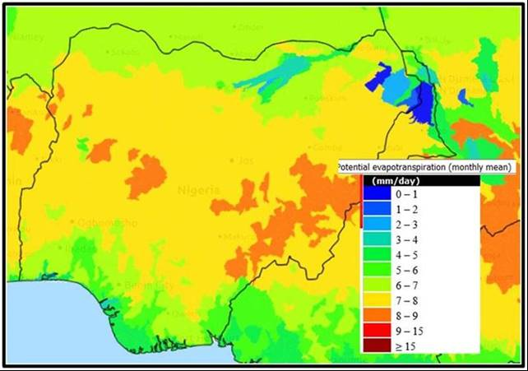
Figure 7: May 2021 Mean Monthly Potential Evapotranspiration Forecast

5.3 Expected Mean Monthly Soil Water Content Forecast
The mean monthly Soil Water Content in May 2021 will range from 0 to 0.1 mm/day in the North and from 0.2 to 0.5 mm/day in other parts of the country as shown in Figure 8.

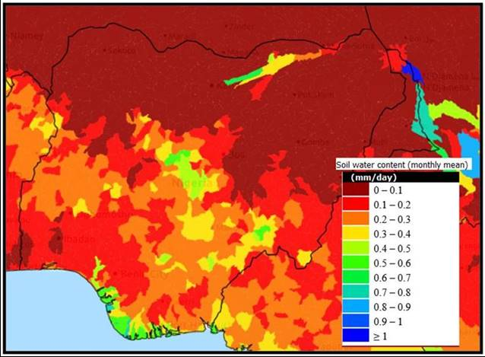
Figure 8: Mean Monthly Soil Water Content Forecast in May 2020

5.4 FANFAR Forecasting for the Month of May 2021 in Nigeria
The European Union Assisted Project – “Reinforced Cooperation to provide Operational Flood Forecasting and Alerts in West Africa (FANFAR)” forecast for Nigeria in May, 2021 (Figure 9) showed low flow event in most parts of the country due to cessation of rainfall except at the Jiderebode upstream Kainji dam where the arrival of transboundary Black flood is still expected from upstream Nigeria with high severity (level 2).
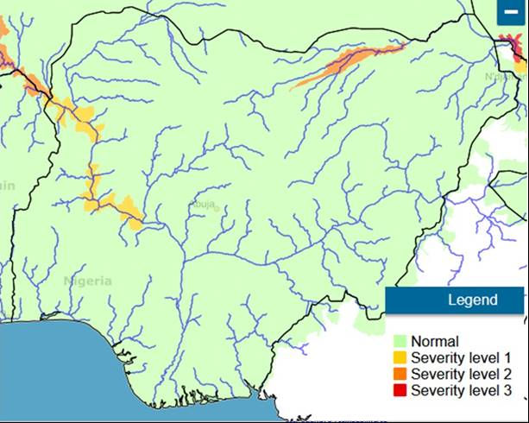
Figure 9: FANFAR Forecasting for the Month of May 2021 in Nigeria
REFERENCES
- Hydrological Data from NIHSA Gauge Stations
- www.sath.abn.ne .
- www.fanfar.eu
- www.platform.princetonclimate.com
- www.climateservice-global.eu
- Vanguard Newspaper

