**NIHSA PREDICTED RED FLOOD ALERT IN 101 LOCAL GOVERNMENT AREAS IN 28 STATES OF NIGERIA IN 2021**

1. **ANNUAL FLOOD OUTLOOK - AFO 2021**

The Nigeria Hydrological Services Agency (NIHSA) has Predicted Red Flood Alert In 101 Local Government Areas in 28 States of Nigeria in 2021/2022 Hydrological Year during the presentation of the 2021 Annual Flood Outlook (2021AFO) that took place at Conference Room of the Ajuji Greenwich Hotel, Abuja on 6th May 2021. This is in line with its statutory mandate which amongst other functions is to issue forecasts on flood, sensitize Nigerians on flood management towards mainstreaming disaster reduction efforts for sustainable socio-economic development. This is intended to sensitize the general public particularly those living in the coastal and riverine areas, cities and communities along the trans-boundary Rivers Niger and Benue that are often at high risk of flooding.

The 9th edition of 2021 AFO was presented by the Honourable Minister of Water Resources Engr Suleiman H. Adamu, FNSE, FAEng. who commended NIHSA for the publication and enjoined the general public, relevant government agencies, research institutions and other stakeholders in the water sectors to use the 2021 AFO in carrying out sensitization and awareness campaigns as well as maintaining the hydraulic structures such as dams and reservoirs to ensure free flow of runoff into drainages and also to remove barriers and construction from the waterways. The 2021 AFO flood scenarios were derived from the application of three reliable models namely HEC HMS Hydrological Model, the Soil and Water Assessment Tool (SWAT) and the HBV Model that utilize meteorological, hydrological and hydrogeological data, topographical and soil water balance indices, as well as Digital Elevation Model (DEM).

**Engr. Suleiman H. Adamu, FNSE, FAEng.**

**Honourable Minister of Water Resources**

The Director General Engr. Clement Onyeaso Nze explained that in addition 101 Local LGAs in 28 States with Red Alert there will be about 302 LGAs in the 35 States of the Federation including the FCT that will fall within the Yellow Alert or moderately probable flood risk areas while the remaining 351 LGAs will be within the Green Alert or low probable flood risks areas as shown in Figure 1. Some coastal States, including Delta, Lagos, and Bayelsa are expected to experience coastal flooding due to rise in sea level and tidal surge which could impact fishing, habitation and coastal transportation. Flash and Urban Floods are also expected to occur in some locations such as Birnin–Kebbi, Sokoto, Kaduna, Gombe, Yola, Makurdi, Abuja, Lafia, Asaba, Port Harcourt, Yenagoa, Lagos, Ibadan, Abeokuta, Benin City, Oshogbo, Ado-Ekiti, Abakaliki, Awka, Nsukka, Calabar, Owerri, Kano, and major cities with poor drainage systems.

**Engr. Clement Onyeaso Nze**

**Director General**

He stated that the simulated hydrographs of gauging stations at Kainji, Ologbo, Kende, Geidam, Ikom, Lokoja, Malabu, Okitipupa, Onitsha, Siluko, Zungeru, Abeokuta, Dadin Kowa, Hadejia, Kafin Gana, Katsina-Ala, Makurdi, Shiroro, Afikpo, Ebba,Gassol, Baro, Kurawa, Umaishia, Otuocha, Wuya, Donga, Chokocho, and Ogun, show gradual increments in flood discharge, which shows that predicted probable flood in 2021 is expected to be similar to that of 2020. He also explained that the flood scenarios presented in the 2021 AFO are derived from the application of three reliable models: HEC HMS Hydrological Model, the Soil and Water Assessment Tool (SWAT) and the HBV Model. These models utilize meteorological, hydrological and hydrogeological data, topographical and soil water balance indices, as well as Digital Elevation Model (DEM). He concluded by urging the members of the public most especially those living within the flood prone areas to be vigilant and take necessary precautional to prevent flood disasters.

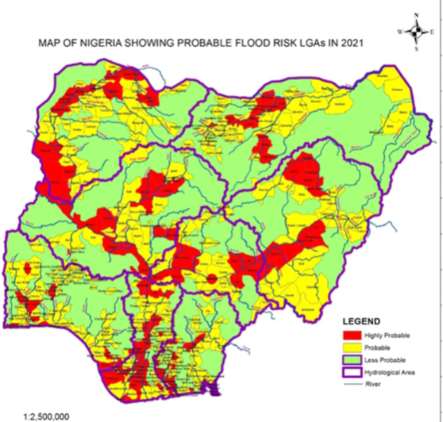

**Fig.1: Map of Probable Flood Risk Areas in Nigeria in 2021 (Source: 2021 AFO)**

**2.0 END OF 2020/2021 HYDROLOGICAL YEAR IN NIGER BASIN**

The 2020/2021 hydrological year that started in June 2020 has ended in May 2021 in the Niger River Basin covering 9 countries of Benin, Burkina Faso, Cameroun, Chad, Cote D’Ivoire, Guinea, Mali, Niger and Nigeria. The Niger Basin is subdivided into 4 sub basins that comprised of: The Upper Niger Basin covering Cote D’Ivoire, Guinea and Mali, The Inland Delta covering Mali, The Middle Niger Basin covering Benin Republic, Burkina Faso and Niger Republic and The Lower Niger Basin covering Nigeria with Cameroun and Chad on the River Benue (Figure 2). The details of River Niger flow situation in Nigeria during the period at the major hydrological stations in the country are as follows:

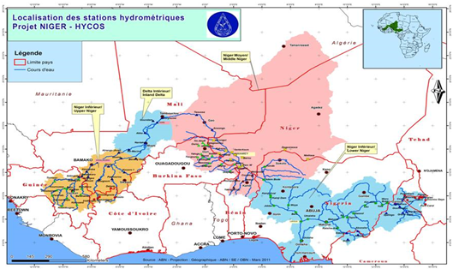

**Fig.2: Map of River Niger Basin with Sub-Catchment Areas**

**2.1 WHITE AND BLACK FLOOD FLOW INTO NIGERIA**

There are two distinct transboundary flood flow of River Niger into Nigeria from Niamey, Niger Republic which are known as the White and the Black floods and both are observed and recorded at Jiderebode located at upstream Kainji and Jebba dams. The maximum White Flood Water Level (WL) occurred during the wet season was 5.36m corresponding to discharge of 5,388 m3/s recorded on 16th September 2020. The Black flood flow maximum WL that occurred during the dry season specifically comes from Guinea was 3.55m which correspond to discharge of 1697 m3/s on 25th February 2021. The flow has continue receding till the end of 2020/2021 Hydrological Year that ended in May 2021 with minimum WL of 0.19m correspond to discharge of 25 m3/ that occurred on 25th May 2021. The Comparative Hydrographs of River Niger at Jiderebode showed that the flow recorded in 2020/2021 hydrological year was lower than those of 2012/2013 and 2019/2020 as shown Figure 3.



Fig 3: Comparative Hydrograph of River Niger at Jiderebode

**2.2 FLOW SITUATION OF RIVER BENUE AT MAKURDI**

The River Benue flow situation at Makurdi during 2020/2021 hydrological year showed a maximum WL of 10.08m correspond to discharge of 14,725 m3/s recorded on 23rd October 2020 and has continued receding in May 2021 with a minimum WL of 3.37m correspond to discharge of 335 m3/s recorded on 13th April. The River Benue at Makurdi has continued receding with minimum discharge of 761 m3/s which occurred on 31st May 2021. The Comparative Hydrographs of River Benue at Makurdi showed that the flow recorded in 2020/2021 hydrological year was lower than those of 2012/2013 and 2019/2020 as shown Figure 4.

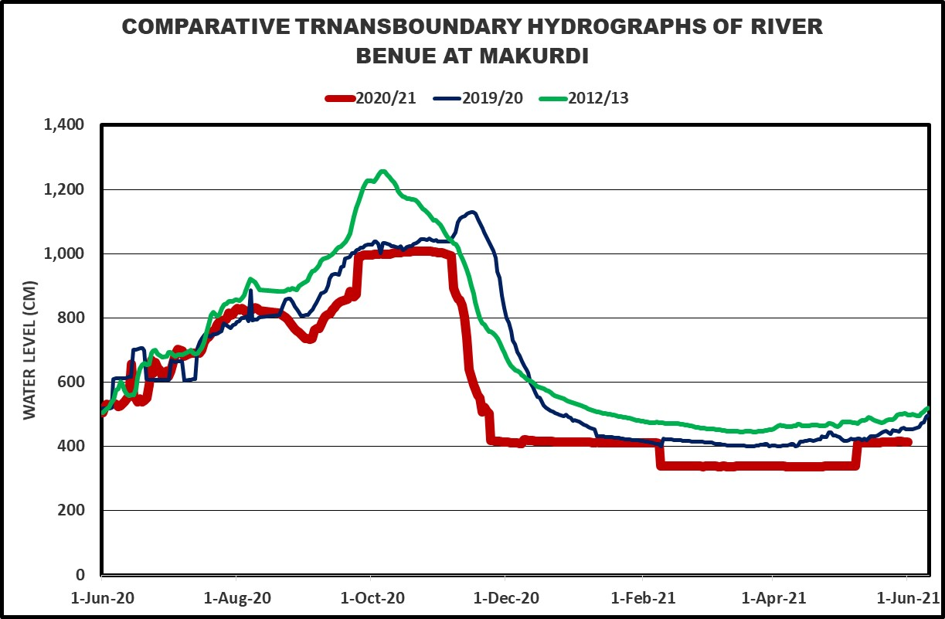

***Figure 4: Comparative Hydrograph of River Benue at Makurdi***

**2.3 FLOW SITUATION OF RIVER NIGER AT LOKOJA**

The River Niger flow situation at Lokoja, Kogi state, attained a maximum WL of 11.89m correspond to discharge of 28,082 m3/s recorded on 5th October 2020 and has continued receding May 2021 with a minimum WL of 3.14m correspond to discharge of 2,697 m3/s recorded on 1st May 2021. The Comparative Hydrographs of River Niger at Lokoja showed that the flow recorded in 2020/2021 Hydrological Year was lower than that of 2012/2013 but higher than that in 2019/2020 (Figure 5).

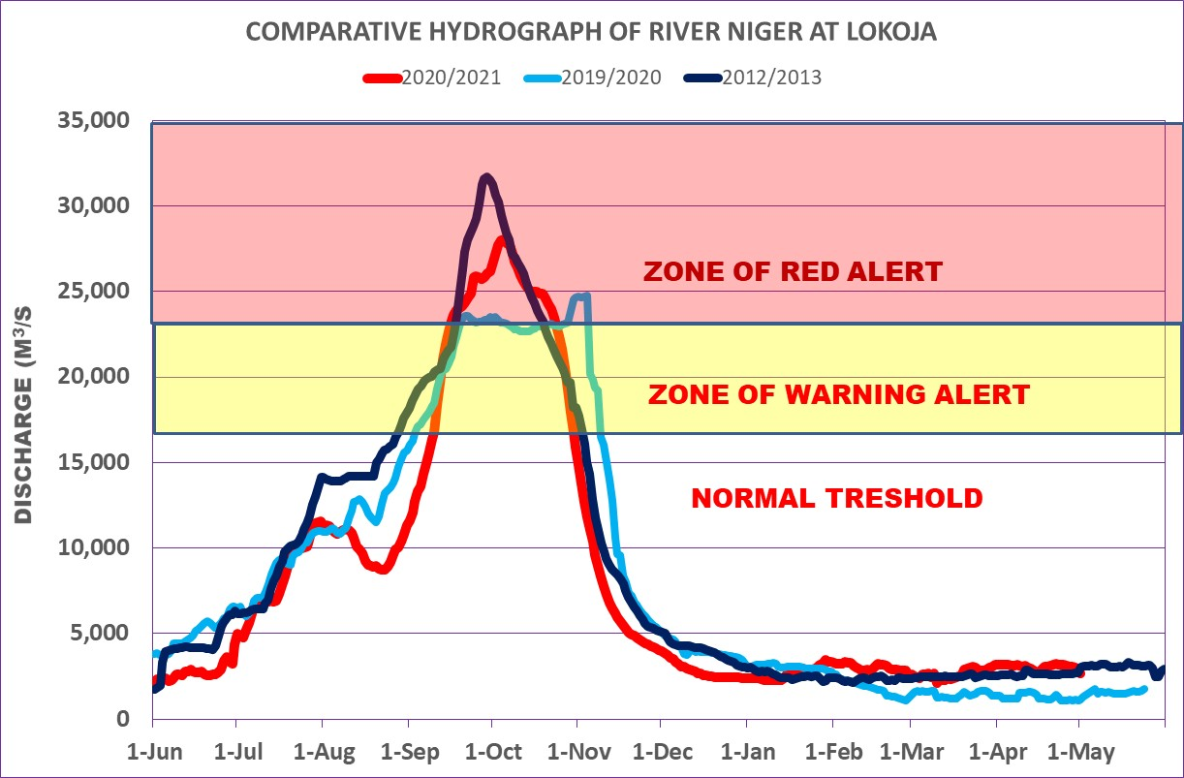

Fig 5: Comparative Hydrographs of river Niger and Benue at Lokoja

**3.0 NIGER BASIN HYDROLOGICAL DROUGHT INDEX**

**3.1 Expected Actual Evapotranspiration in June 2021**

The Actual Evapotranspiration rate forecast in June 2021 will range from 1000 to 1500 mm/year in most parts of the river Niger Basin in the country except along the North Eastern part where it will range 600 to 1000 mm/year (Figure. 6).

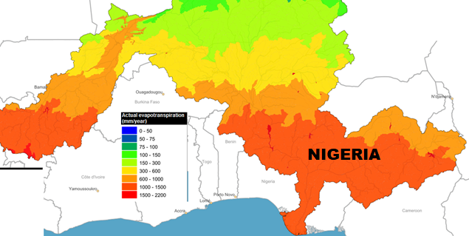

**Fig. 6: Mean Monthly Actual Evapotranspiration Rate Forecast in May 2021 in Niger Basin in Nigeria**

**3.2 Expected River Discharge**

The expected river discharge forecast in June 2021 will range from 500 to 5000 m3/s along the river Niger and Benue and between 5 to 50m3/s in other part of the country (Figure 7).

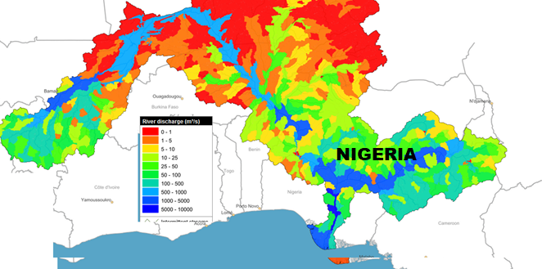

**Figure 7: May 2021 Mean Monthly Potential Evapotranspiration Forecast in Niger Basin in Nigeria**

**3.3 Expected Mean Monthly Soil Water Content Forecast**

The mean monthly Soil Water Content in June 2021 will range from 100 to 400mm/year in most parts of the river Niger Basin in the country except towards the South Eastern part where it will range 4000 to 750 mm/year Figure 8.

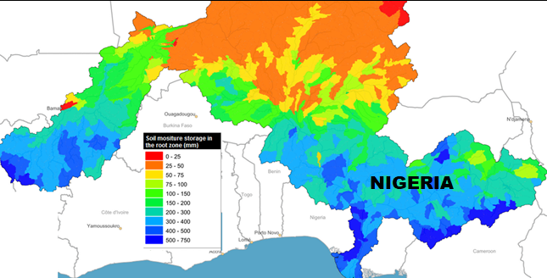

**Figure 8: Mean Monthly Soil Water Content Forecast in May 2020 in Niger Basin in Nigeria**

**3.4 FANFAR Forecasting for the Month of May 2021 in Nigeria**

The European Union Assisted Project – “Reinforced Cooperation to provide Operational Flood Forecasting and Alerts in West Africa (FANFAR)” forecast for Nigeria in May, 2021 showed low flow event in most parts of the country due to cessation of rainfall except at the Jiderebode upstream Kainji dam where the arrival of transboundary Black flood is still expected from upstream Nigeria with high severity (level 2) shown in Figure 9).

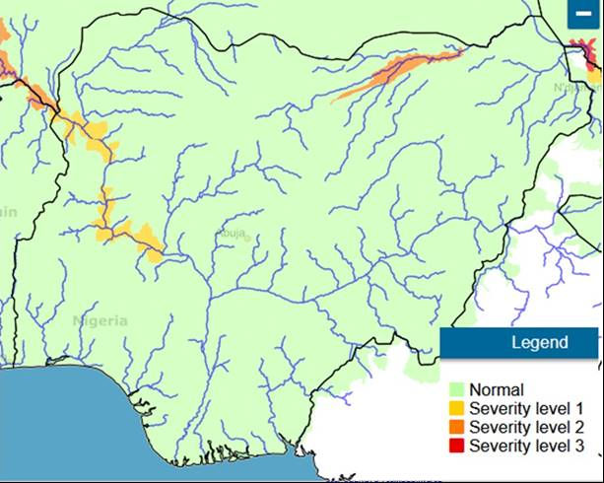

**Figure 9: FANFAR Forecasting for the Month of May 2021 in Nigeria**

**REFERENCES**

1. Hydrological Data from NIHSA Gauge Stations
2. [www.sath.abn.ne](http://www.sath.abn.ne) .
3. [www.fanfar.eu](http://www.fanfar.eu)
4. [www.platform.princetonclimate.com](http://www.platform.princetonclimate.com)
5. [www.climateservice-global.eu](http://www.climateservice-global.eu)
6. <https://hypeweb.smhi.se/>